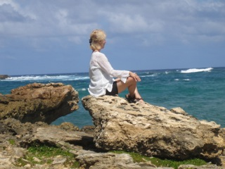
“Fifth Annual”
Unplug, Unwind
and Rediscover
Peace & Joy

June 23rd, 9:30am- 4: 30pm
Wiawaka Center for Women
Lake George, NY

Join us for this very special retreat day designed for professional women (all women) who are caught between the demands of career, family, and the multiple demands of busy lives. Join Mary Scott for a day dedicated to coming back to yourself, and discovering peace and joy right where you are, while nurturing calmness and clarity and feeling deep layers of stress melt away. Together we will practice mindful and healing yoga, guided mindfulness meditations, group and partner practices to enhance awareness and open the heart, yoga nidra / deep yogic sleep, all surrounded by the bliss of a wonderful natural setting.
Leave feeling rested and relaxed with experiences you can take home with you to continue your practice. No yoga or meditation experience is required. Dress in comfortable clothing for movement and bring a sweater or jacket if weather calls for it. Bring your bathing suit for a dip in the lake.
The fee for the day is $45. Bring your own lunch or lunch can be pre-ordered from Wiawaka for $12. To register for the retreat day e-mail Mary at maryjscott26@gmail.com or call 518- 346-7389.

THE ENROLLMENT CUT OFF IS 20 PARTICIPANTS. PLEASE DO NOT WAIT TO REGISTER, AS THIS PROGRAM FILLS QUICKLY.

To pre-order lunch please contact Wiawaka directly at 518- 668-9690.
To make this an extra special retreat experience you may stay on site at Wiawaka. Link to accommodations ; https://wiawaka.wordpress.com/plan-your-stay/accommodations/ To make a reservation contact Wiawaka; 518-668-9690.

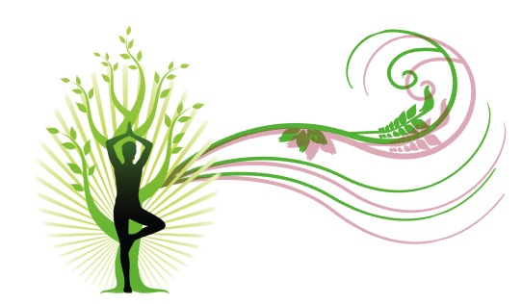
Mary Scott Yoga Therapy LLC

