“ The natural comfort and joy of our being is expressed when the body becomes steady (asana).”

II.46 Patanjali Yoga Sutra

interpreted by Nischala Devi

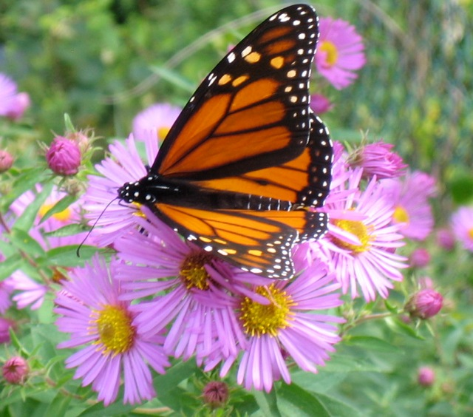

**YOGA OFFERS A PATHWAY WHICH LINKS BODY AND MIND, RESTORES BALANCE, AND ALLOWS HEALING OF BODY, MIND, AND SPIRIT**

**TO OCCUR.**

Contact the Instructor at

346-7389 or

[maryjscott26@gmail.com](mailto:maryjscott26@gmail.com)

www.maryscottyogatherapy.com

**Sunnyview Lifestyle Wellness Center**

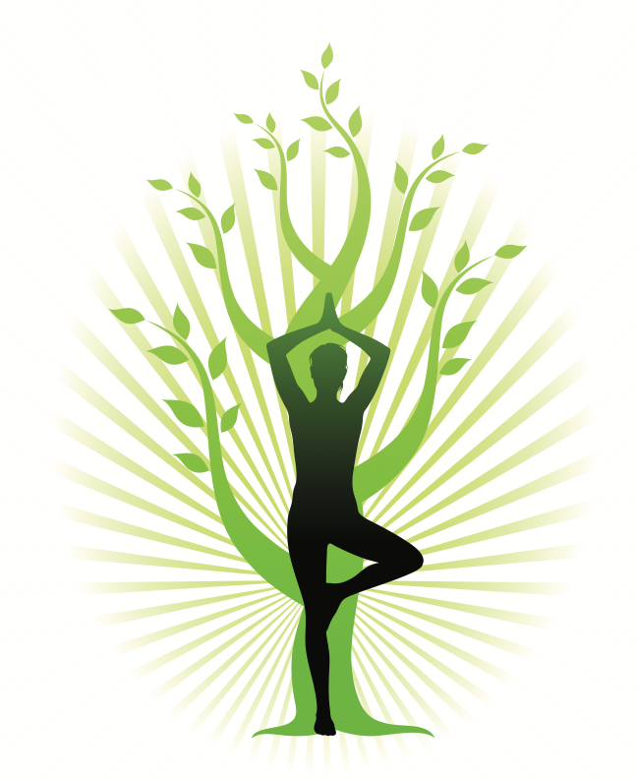

**SHAKE OUT YOUR SHOULDERS, NECK,**

**AND UPPER BACK**

**A 4-week Yoga Therapy**

**Program**

**with**

**Mary J. Scott MA, RYT500**

**C-IAYT,Structural Yoga Therapist**

**Begins on Wednesday,**

**July 12- August 3**

**Time: 6- 7:15**

**YOGA**

**A Healing Path**

**Do you carry tension in your upper back, neck and shoulders?**

**Do you want to learn how to release that tension and find a new sense of fluidity in your upper body?**

This four class yoga therapy program

is designed to give you the tools you need to create balance, strength and flexibility of the shoulder girdle and spine, learn new postural habits, and loosen up the tight gripping of chronically overworked muscles.

Through regular practice of therapeutic yoga, participants can

decrease upper back discomfort and improve the quality of life.

We will practice therapeutic yoga postures, freeing motions, breathing techniques, and guided relaxation, as well as education on posture and self care.

This class is appropriate for yoga students of all levels. The series introduces both seasoned practitioners and beginners to the appropriate application of yoga therapeutics.



CLASS LOCATION

**Sunnyview Rehabilitation Hospital:**

1st Floor Conference Rooms

Belmont Ave., Schenectady, NY

Begins on Wednesday July 12,

Then Thursdays July 20, 27,

and August 3. Time: 6- 7:15

Program Fee: $65 is paid upon registration. Please contact the instructor directly to enroll.

Tel: 346-7389 or

[maryjscott26@gmail.com](mailto:maryjscott26@gmail.com)

**Mary J. Scott MA, RYT® 500,**

**C-IAYT®**

**Structural Yoga Therapist™**

Mary brings an exceptional sensitivity to her Yoga Therapy work and yoga instruction from her years of experience in creating and adapting yoga and fitness for clients’ special situations, as well as her own personal healing through yoga therapy.

Mary has been teaching yoga for over a decade and has taught all the yoga classes in the Sunnyview yoga program for the past ten years. She holds certifications as a Structural Yoga Therapist™, a Structural Yoga Teacher, and a Yoga of the Heart® Teacher. Mary’s yoga training is grounded in the classical yoga and healing tradition of Krishnamacharya and culminated in the 750 hour program for Structural Yoga Therapists™, which she completed in 2008. In 2012 Mary completed the Essential Back Teacher Training Program with Robin Rothenberg. This program was highlighted in the research study of yoga for back pain and published in the Annals of Internal Medicine. Mary is a member of IAYT, The International Association of Yoga Therapists and achieved Certification by IAYT in 2017. Mary is also a Mindfulness-based Stress Reduction Teacher, trained at the UMass Clinic of Dr. Jon Kabat-Zinn, and has taught mindfulness-meditation for many years.

